**Oodaloo and RowCol: Narrative Summary**

### **The Insight**

At the center of both Oodaloo and RowCol is one simple but powerful idea: the **Cash Runway Ritual**. Every week, business owners and (if they can afford it) their CPAs/bookkeepers sit down—formally or informally—to answer the same three questions:

1. Can I cover payroll and core bills next week?
2. Which clients are late and need chasing?
3. Which vendors must I pay now, and which can wait?

This ritual connects a business’ operations to its financial reality at the point of maximum relevance. Yet no tool supports it. There are compliance-oriented tools that support tax liability and ops-oriented tools to support business operations. And there are even tools for handling one side of the problem either AR or AP. But where they connect to actually prioritize and make decisions, that work today is manual, spreadsheet-driven, and inconsistent—the perfect conditions to turn a **repeatable, time-bound, high-touch, high-value process touching money into a product**.

And because CAS (Client Advisory Services) is the fastest-growing segment of accounting, and firms want to create more regular touchpoints with clients beyond annual tax or compliance, this ritual is a **massively under-served wedge** into a broader wave of growth in Accounting Tech.

### **The Journey**

My career has been about automating ops/financial workflows:

* **Gaggle** – high-stakes classification at scale.
* **ACV** – document processing.
* **Aiwyn** – enabling accounting firms.
* **Spring** - supply/demand matching
* **Found** – transaction categorization for bookkeepers.

With new AI coding tools, I can build the kind of high-impact financial tools professional services actually value—tools that touch money. QuickBooks Online (QBO) already dominates SMB accounting, their platform APis are comprehensive and resilient for building advanced capabilities, and their app marketplace provides global distribution to high-intent buyers. CAS firms, meanwhile, are hungry for tools that make their work faster, more visible, and more profitable.

As I’ve systematically tested multiple ideas (fixed assets, close automation, bookkeeping automation, service ops) for how it mapped to the transferable core of my past successes, in hindsight I can see that through each exerience I was picking up one piece of the puzzle I needed to even recognize the **weekly cash runway ritual** for the opportunity that it is: Universally needed yet somehow underserved, unclaimed territory, a place to invest.

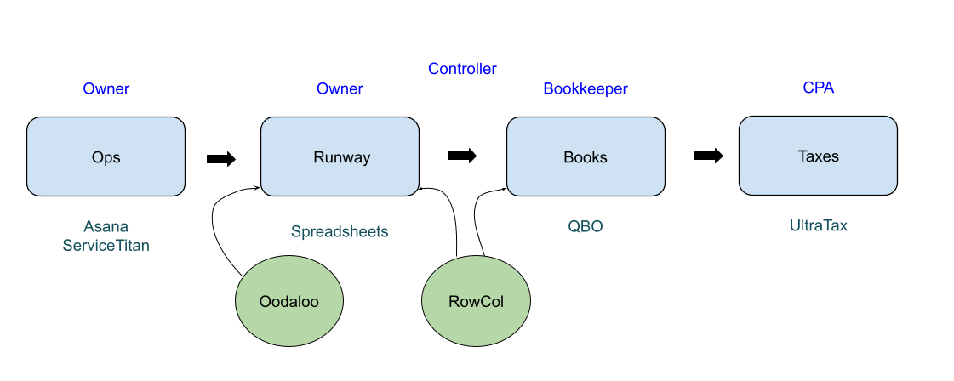

*Diagram shows how Oodaloo/ RowCol fit within business ops-finance flow.*

### **Oodaloo: The Weekly Cash Runway Ritual**

For creative/marketing/IT agencies ($1–$5M revenue, 10–30 FTE), Oodaloo fills the missing layer between ops platforms (e.g., Asana, Monday) and QBO. It acts as the “observe, orient, decide, act” ritual (the OODA loop) for financial decisions:

* **Weekly Digest:** One-page Friday pack showing Cash Runway, AR aging (>30/45d), AP due ≤14d, and clean-books meter. Delivered by email/Slack with deep links into QBO.
* **Prep Tray:** Clean up any dangling AR/AP. Then group bills into Must Pay vs Can Delay, surfacing the few real decisions that matter.
* **Smart Collections:** Optional add-on ($49/mo) to automate invoice reminder sequences.
* **QBO Integration:** Runs entirely on QBO’s rails (Invoice.Send, BillPayment scheduling).

**Market Opportunity:** ~150k U.S. agencies fit this profile. At $199/mo, that’s ~$360M/year TAM. Capturing 0.5–1% (500–1,000 users) = $1–2M/year by 2027.

### **RowCol: Empowering CAS and vCFO Firms**

For firms running this runway ritual across 5–50 clients, RowCol extends Oodaloo’s model with a **multi-client console**:

* **RowCol Runway:** Batch weekly packs, clean-books scoring, role-based access, light analytics.
* **RowCol Close:** Monthly close workflow (checklists, reconciliations, JEs), to round out their regular requirements.

Because CAS firms do more than just the runway ritual, RowCol would need to over a more comprehensive offering to encompass both the weekly runway ritual and the more compliance driven monthly close checklist. And because what firms needs is much more than is typically offered via the QBO app marketplace, it makes more sense to build, brand, price, and market it for firms as the core user.

**Market Opportunity:** ~10k U.S. CAS/vCFO firms. At $1,000/mo average, ~$120M/year TAM. Capturing 1–2% (50–100 firms) = $500k–1M/year by 2028. Once Oodaloo is proven out, can wrap RowCol capabilities around it.

| Aspect | Accounts Receivable | Cash | AP | Incomplete Data |
| --- | --- | --- | --- | --- |
| Tension | Prepping new invoices, matching payment to invoices, and chasing overdue invoices | Unclear reserves given AR and AP timing against regular expenses | Prioritizing pay/delay per bill | Both invoices and bills can have missing required fields, QBO hard to navigate. Payments may not match invoces |
| Oodaloo Solution | Smart Collections email drip campaigns allows for personalized and better control over collections while still operating on QBO’s native functionality | Cash Runway metric, flagging risks via alerts  Prioritize invoices and bills that would improve cash position. | Auto-chunk bills into priority groups and sort against impact on Cash Runway. with Scheduling for Timeline Release as Runway opens up | Weekly Email curates all the necessary views for owner to observe, orient  Prep Tray UI to decide and act |

*Table shows AR / Cash / AP / Data Issues tensions and how Oodaloo addresses them (Smart Collections, Runway metric, Prep Tray, Hygiene).*

### **Why It Works**

The **weekly cash call** is already viewed as controller-level, high-leverage work. But until now, only companies with internal finance teams or external CAS firms had the resourcing to manually pull it together on a consistent basis. Oodaloo productizes the ritual by building on the AR/AP/QBO systems that are there already: it’s light enough for an owner to self-serve, structured enough for a bookkeeper to uplevel, and scalable enough for CAS/vCFOs to serve dozens of clients.

Distribution is strong:

* **QBO App Store** = high-intent buyers searching for “cash flow.”
* **CAS firms** = fastest-growing service line, needing tools to prove value weekly.
* **Owners** = willing to pay more for decision surfaces over just more dashboards, because this ties directly to weekly peace of mind.

At the nexus of cash-in, cash-out, and cash-on-hand, Oodaloo and RowCol stand where owners and accounting pros meet every week. That makes this tool indispensable—and gives it pricing power—while incumbents are still focused on making tax and compliance more polished, the messy middle is where the opportunity lies.